Online Event Organizers



Deliverable: Project Proposal

Submitted By:

Hassan Anwar | BSEF12M014
Muzamil Ejaz | BSEF12M054
Hisham Zahid | BSEF12M025
Badar Iqbal | BSEF12M038
Raza Ahmed | BSEF12M061

Project Supervisor:

Nastaeen Fatima

Table of Contents:-

1-Project Overview 1
2-High Level System Components 4
3-List of Optional Functional Units 6
4-Exclusions 6
5-Application Architecture 6
6-Gantt Chart 7
7-Hardware & Software Specifications 8
8-Tools and Technologies 8

- Project Overview:
Online Event Organizers is an online web-based system for users to organize different kind of events and providing a facility to plan their events according to their budget. It also facilitates the user in order to search different Event Organizers Companies, see their packages, services and bookings and plan the event accordingly.

1.1- Project Overview Statement:-

Project Title:
Online Event Organizers.

Group Leader:
Hassan Anwar.

Project Members:
Name | Registration # | Email Address | Signature
Hassan Anwar |  | Bsef12m014@pucit.edu.pk
Muzamil Ejaz |  | Bsef12m054@pucit.edu.pk
Hisham Zahid |  | Bsef12m025@pucit.edu.pk
Badar Iqbal |  | Bsef12m038@pucit.edu.pk
Raza Ahmed |  | Bsef12m061@pucit.edu.pk

Project Goal:
The main goal of the project is to provide an online solution for event services and making event management easy. While planning, people undergo a lot of troubles at the hands of the Organizing companies who dodge their customers and give different rates to different people. Online Event Organizers provides different packages offered by the companies with in their budget having details of their facilities and services. In this way users can easily search and compare and can be able to select a company according to their requirements so that they don’t go over-budget. It also provides the facility to contact the Vendor companies in order to book their events.

Objectives:
- Making event planning process smarter and easier.
- Time and money saving event planning for users.
- Search and compare different packages and services provided by different vendors companies.
- Search vendors according to the budget range provided by the user.
- Online booking of vendors for event upon their availability.
- Customer communication with the vendors and companies.
- Total budget calculation for the event.
- User friendly GUI.

Project Success Criteria:
System should be delivered in time having all the functionalities implemented and validated and end users are satisfied with all of the system functionalities.

Assumptions, Risks and Obstacles:
Limited time.

Type of Project:
Development.

Organization Address:
Punjab University College of Information Technology,
University of the Punjab, Lahore.

Target End Users:
General Users.

Development Technology:
Object Oriented.

Platform:
- Web application.
- Mobile application.

Suggested Supervisor:
Nastaeen Fatima.

Approved By: Nastaeen Fatima.
Date: Thursday, October 22, 2015.

- High Level System Components:

- Sign in/Sign up for Users:
Users have to sign-up to the website in order to avail all the facilities provided by the website. Specific functionalities will be available for logged out users.

- User status and Profile Management:
Status of user visiting website will be shown to the user. Users can also edit their profile details and manage them.

- Search Filters:
Different filters will be available for users to search different companies. User can search companies on basis of Budget range, Event type, Company/Vendor type, Services type and Locations.

- View Services Details:
User can view all details related to Company/Vendor and their Services related to the event.

- Check Availability:
User can check availability of the Company on desired date and time and can make his selection accordingly.

- Book Events:
User can book the selected Company for the event. For this a request is made to the Company to book the event.

- Company/Vendor Profile Management:
Companies/Vendors will have a profile on the system on which they can modify details, services and availability.

- Advance Payment Management:
In order to book the event, user has to pay some advance amount to book the concerned company/vendor. For this payment handling will be managed.

- Edit Services:
While booking some company/vendor, users will have the facility to select their own desired services they want to avail in order to make their budget as efficient as possible.

- Company/Vendor Categories:
Different kind of companies can be searched according to customer desire. Vendor categories will be shown to the users.

- Total Budget Calculation:
Total event cost will be calculated and shown to the user upon selections of all the services and vendors booked for the concerned event.

- Company/Vendor and Customer communication:
Customer can easily communicate with the concerned vendor/Company via Chat boxes and emails.

- Company/Vendor Rating & Reviews:
Company/Vendor Rating and Reviews can be made by the customers in order to enhance their ratings.

- List of Optional Functional Units;

- Online payment methods through online money transfer services.

- Admin has an access to all the functionalities in order to monitor the whole system activities.

- Exclusions:
Cloud Database.

- Application Architecture:
MVC Architecture.

- Gantt Chart:

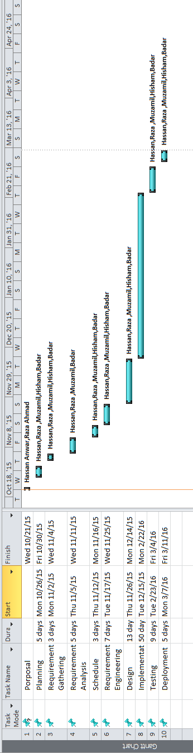

- Hardware & Software Specifications:
Hardware:
Intel Core i3 processor Systems.

Software:
Microsoft Windows 7 Ultimate Operating System.

- Tools & Technologies:
Tools:
• Eclipse – Android Development in Java
• Android Studio – Android Development in Java
• NotePad++ – Coding
• Adobe Photoshop C6 – Designing & Editing Pictures
• SQL YOG – Database Handling
• Xamp server – LAMP Environment
• NetBeans (IDE) – Coding
• IBM Rational Rose – UML Diagrams
• Microsoft Project Manager – Schedules, CPM, Gantt chart

Technologies:
• PHP (Yii Framework 1.1.x)
• Android Java
• MySQL
• Bootstrap
• JavaScript / Jquery
• HTML 5
• Restful Services (Web Services)
• Google Maps
• CSS 3
• AJAX
• Angular.Js

Development Process:
Iterative Development process.

